Khuzaima Mushatq  
CSS 432

HTTP Server and Retriever

My project has 3 cpp files, client.cpp, the retriever, server.cpp, the server, AND clientT.cpp this is the retriever that interacts with my server since my server runs on port 5555 not 80, since 80 is taken. Simple change port in code to switch it to port 80.

**Real Web Browser Accessing my Server:**

I was unsure how to write a script to access my server through a real web browser.

**Your Retriever Accessing a real Server:**

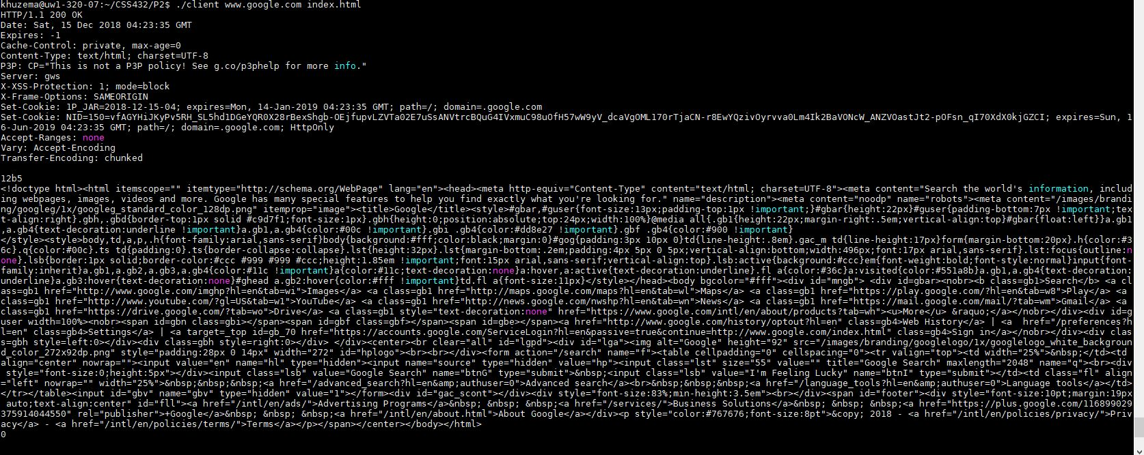

This shows my retriever accessing [www.google.com](http://www.google.com) and asking for index.html. My retriever unfortunately can not GET img and script tags. I tried to implement it but the request wouldn’t go through. I do have the code in the client.cpp it has been commented out. At the end of displaying the document that we get, I do display the names of the images to get. But my get requests to get those images fail. I also get all the script tags but the requests for them also failed.

If you initially try to request a image though, it does work.

**Your Retriever accessing a file from your server:**

My server runs on port 5555 because port 80 is taken.

1. **The request that my server received doesn’t make sense**.

Bad syntax, etc. In this case my server sends back a error 400 bad request with a custom bad request page

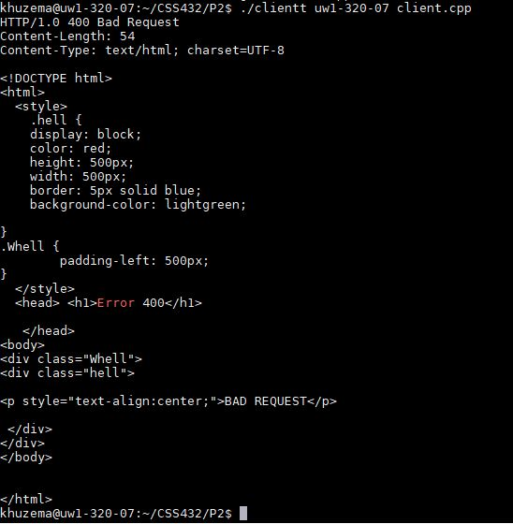

1. **The file requested is not found**

In this case my server sends back an error 404 file not found with a custom error 404 page

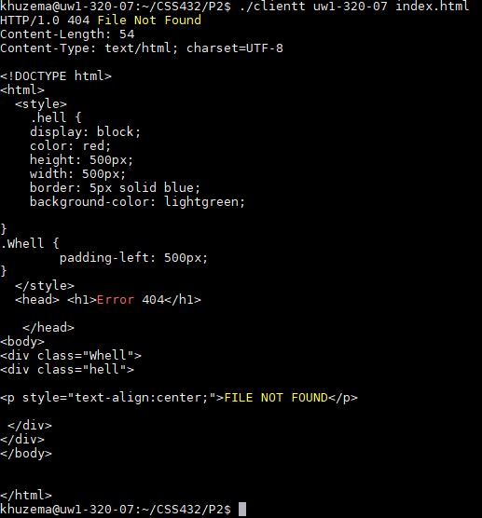

1. **File requested is found**

In this case my server sends a 200 OK with the file that was requested

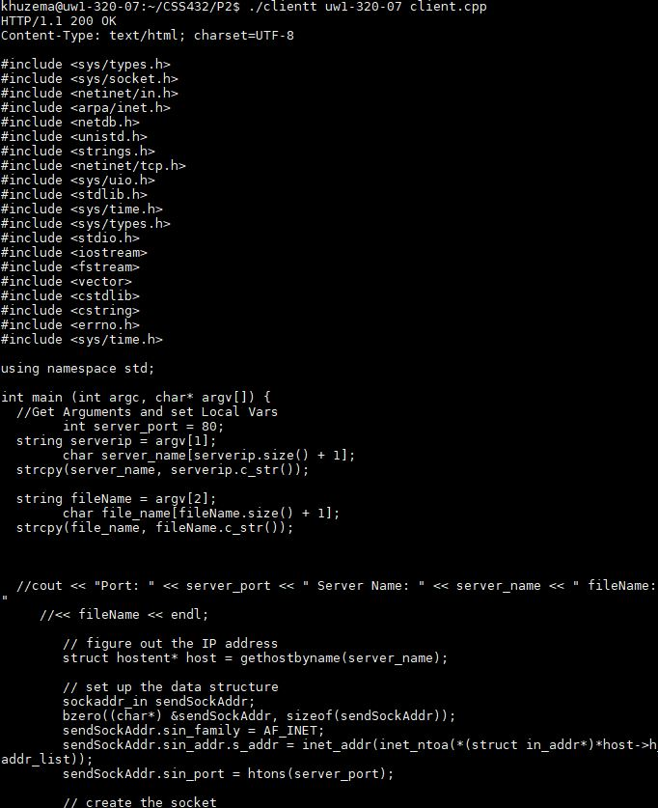

**On my Servers side these requests show as:**

